Retrospect of University History · Founding Father of Modern Accounting in China - Pan Xulun
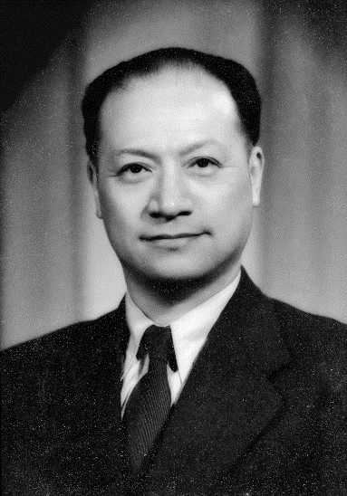
Pan Xulun (1893-1985)
Mr. Pan Xulun, founder and former president of Lixin, born in Dingshu Town, Yixing, is an internationally renowned accountant and educator and is known as the “Founding Father of Modern Accounting in China”.
- Great twists and turns in early life
Born in a family of scholar, Pan Xulun was smart and studious with outstanding academic record since childhood. Before 12, Pan studied in an old-style private school. Then, he entered Dongpo Elementary School, and after that, Shanghai Pudong Middle School, where he was appreciated by president Huang Yanpei.
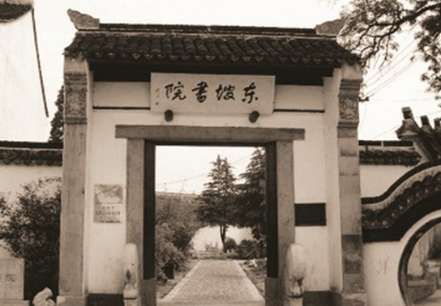
In 1905, Pan Xulun studied in Dongpo Elementary School
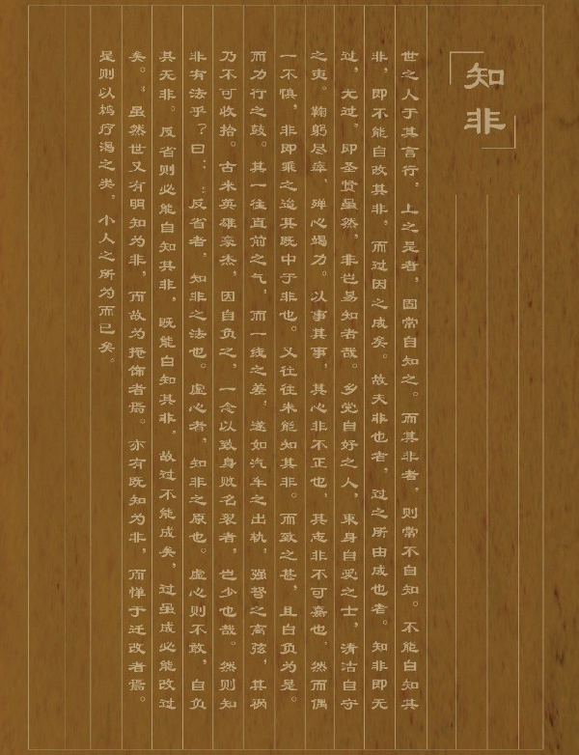
Composition titled Introspection (Zhi Fei) written by Pan Xulun when he was studying in Shanghai Pudong Middle School
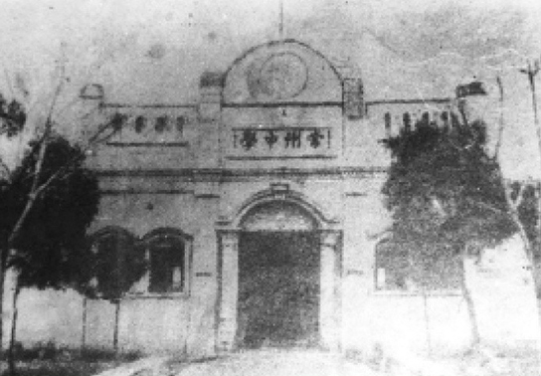
In 1908, Pan was dismissed from school for being involved in a protest against a teacher by handing in blank examination paper. Then, Pan transferred to Changzhou Middle School.
(With a long history, Changzhou Middle School has cultivated a number of celebrity alumni, including Qu Qiubai and Qian Mu).
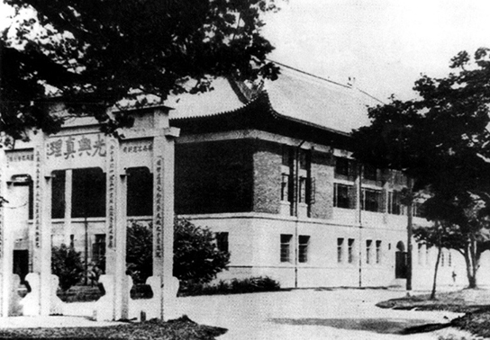
In 1919, Pan obtained an exceptive admission to St. John’s University.
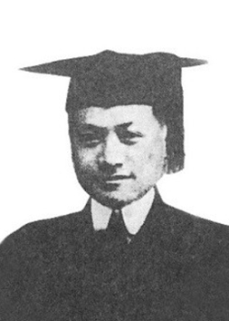
In 1921, Pan obtained a Bachelor of Arts degree.
- Travel across the ocean to study
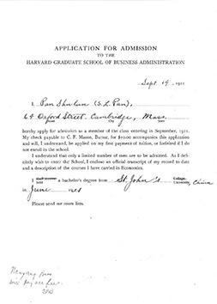
Pan Xulun’s Application for Admission to Harvard University
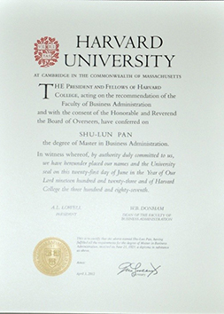
Pan Xulun’s Graduation Certificate from Harvard University
In 1921, Pan Xulun won the scholarship of Nanyang Brothers Tobacco Co. Ltd. via examination and went to the U.S., to study in Harvard University School of Business and Management. He chose the major of accounting and thus laid firm foundation for the lifelong engagement in accounting researches. After two years of hard study in Harvard University, Pan obtained MBA degree. Then, he spent another year in Columbia University studying political economy and obtained doctor’s degree.
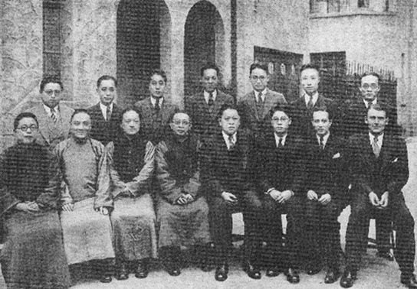
Photo of Pan Xulun and Harvard University Alumni Association Shanghai Chapter in July 1936
- Devote himself to accounting and found Lixin
In 1924, Pan Xulun graduated and returned to China with the wish to “save the nation by education” and “save the nation by engaging in industry”. After coming back to Shanghai, he introduced and taught western accounting in several universities in succession. As the earliest promoter of new bookkeeping system and the founder of modern accounting in China, Pan is called the Founding Father of Modern Chinese Accounting.
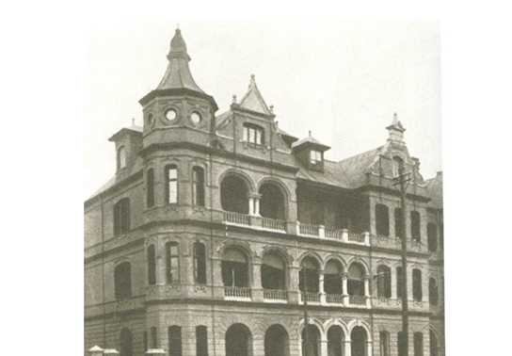
Lixin Accounting Firm founded in Avenue Eduard Ⅶ (Yan’an E. Road today)
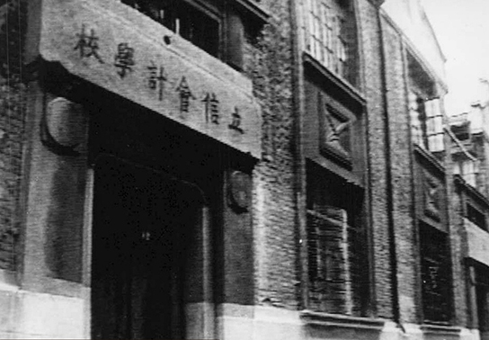
Former site of the school headquarters at No.18, Jixiangli, He’nan Road, Shanghai
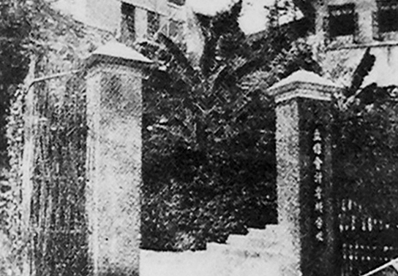
School campus in Beibei
Lixin Accounting Book Store at No.16, Linsen Road, Chongqing
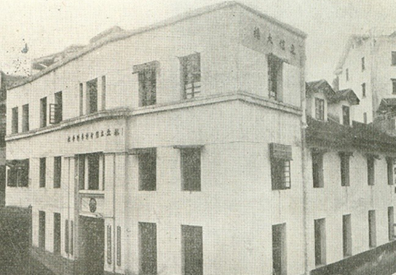
“Lixin Building” on Kuaizi Street, Xiaoshizi, Chongqing
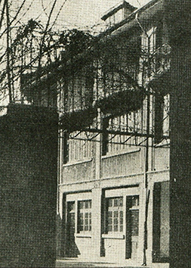
Residence of Pan Xulun on Changle Road, which he devoted to the school as temporary school building
- The old horse in stable is yet dreaming of heroic exploits
In the 1950’s, Pan Xulun suffered from significant setbacks. Then, he kept his beards to show his moral courage and pursuit. The school stopped running for adjustment in 1952. In the late 1970’s, the identity of Pan Xulun as CPPCC member of Shanghai was recovered.
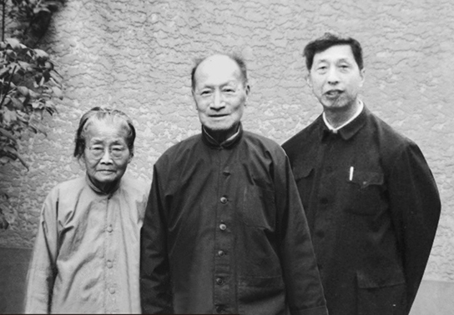
Photo of Pan Xulun, his wife and Pan Zengxi, his grandnephew, in 1979
(Pan Zengxi: former vice general manager of China State Shipbuilding Corporation and former vice president of Xinhua News Agency Hong Kong Branch)
After the implementation of reform and opening-up policy, Pan Xulun continued to be active practitioner in the field of accounting. As proposed by Pan Xulun, Shanghai Accounting Association, the first accounting association in China, was founded in 1979.
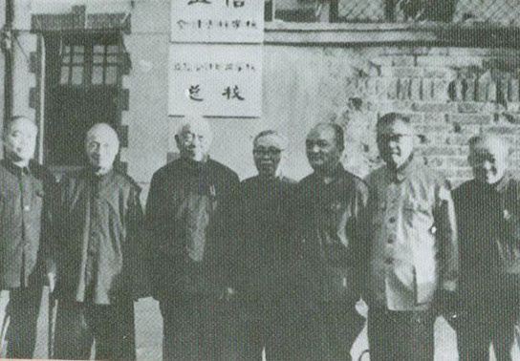
In August 1980, 11 celebrities from social and economic circles, including Pan Xulun, Ma Yihang and Gu Shuzhen, proposed recovering Lixin and founding Lixin College of Accounting.
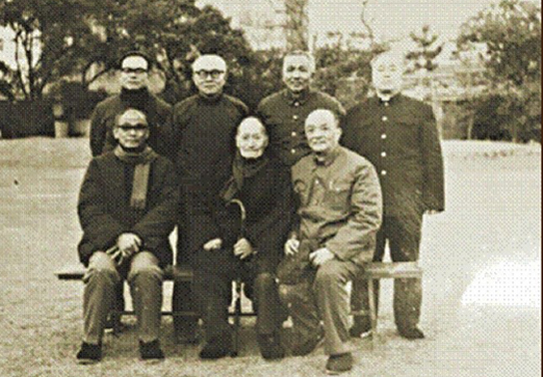
In January 1981, Shanghai Accounting Firm was founded. This was the first accounting firm in China with Pan Xulun acting as the first chairman.
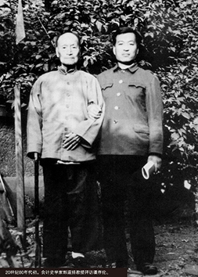
In the 1980’s, accounting historian Professor Guo Daoyang visited Pan Xulun.
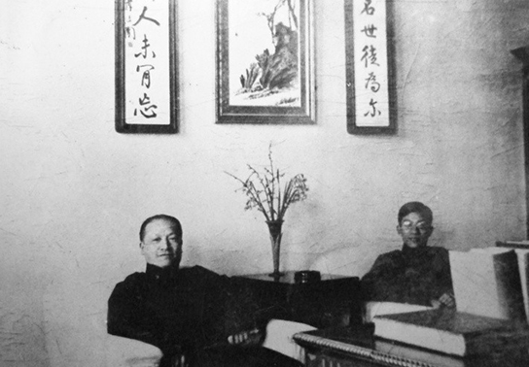
In the 1950’s, Pan Xulun took a photo with Gu Zhun, a student of Pan, and Director General of Shanghai Municipal Bureau of Finance.
- Pan lived a simple, thrifty and charming life
Pan Xulun devoted himself to accounting and accounting education in China. Pan set up “Siyuan Education Foundation” for Nanyang Tobacco Corporation, which used to subsidize him. In 1937, he donated 60,000 Yuan to establish Lixin College of Accounting. In 1980, he donated his lifelong savings for the rebuilding of the school and set up Pan Xulun Scholarship. Pan invested all books he collected and all his royalties on books into the accounting education. However, Pan lived a very simple and thrifty life.
On Nov.8, 1985, Pan Xulun died of an illness at the age of 92. As a leading authority in accounting, founder of Lixin and a great figure in Chinese academic and accounting field, Pan Xulun will surely have his name and contributions to Lixin and accounting recorded in the development history of accounting and the history of modern education in China.
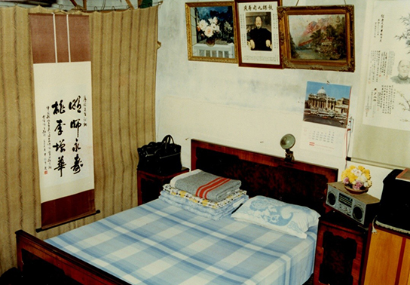
Residence of Pan Xulun and his wife Zhang Huisheng in their late years
- Quotations from Pan Xulun
- Accountant should have impartial character, sincere attitude, incorruptible integrity, and hardworking spirit to advance credit and perform duties.
- Knowledge, experiences and skills are all essential qualities of an accountant, but what is most important is definitely morality.
- Achievements can only be made after we work hard to run a school. Special talents can only be cultivated by combining theory with practices.
- For an accountant, only full score is qualified. 1 point less is below the standard.
- From the society, to the society. From the accounting, to the accounting. From the students, to the students.
- Equip Students with Knowledge, Integrity and Loftiness
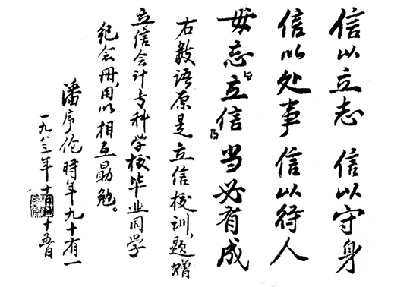
Previous School Motto (Handwriting of Pan Xulun)
Link to news: http://xww.sfu.edu.cn/ts/47843.htm

